Network Theory

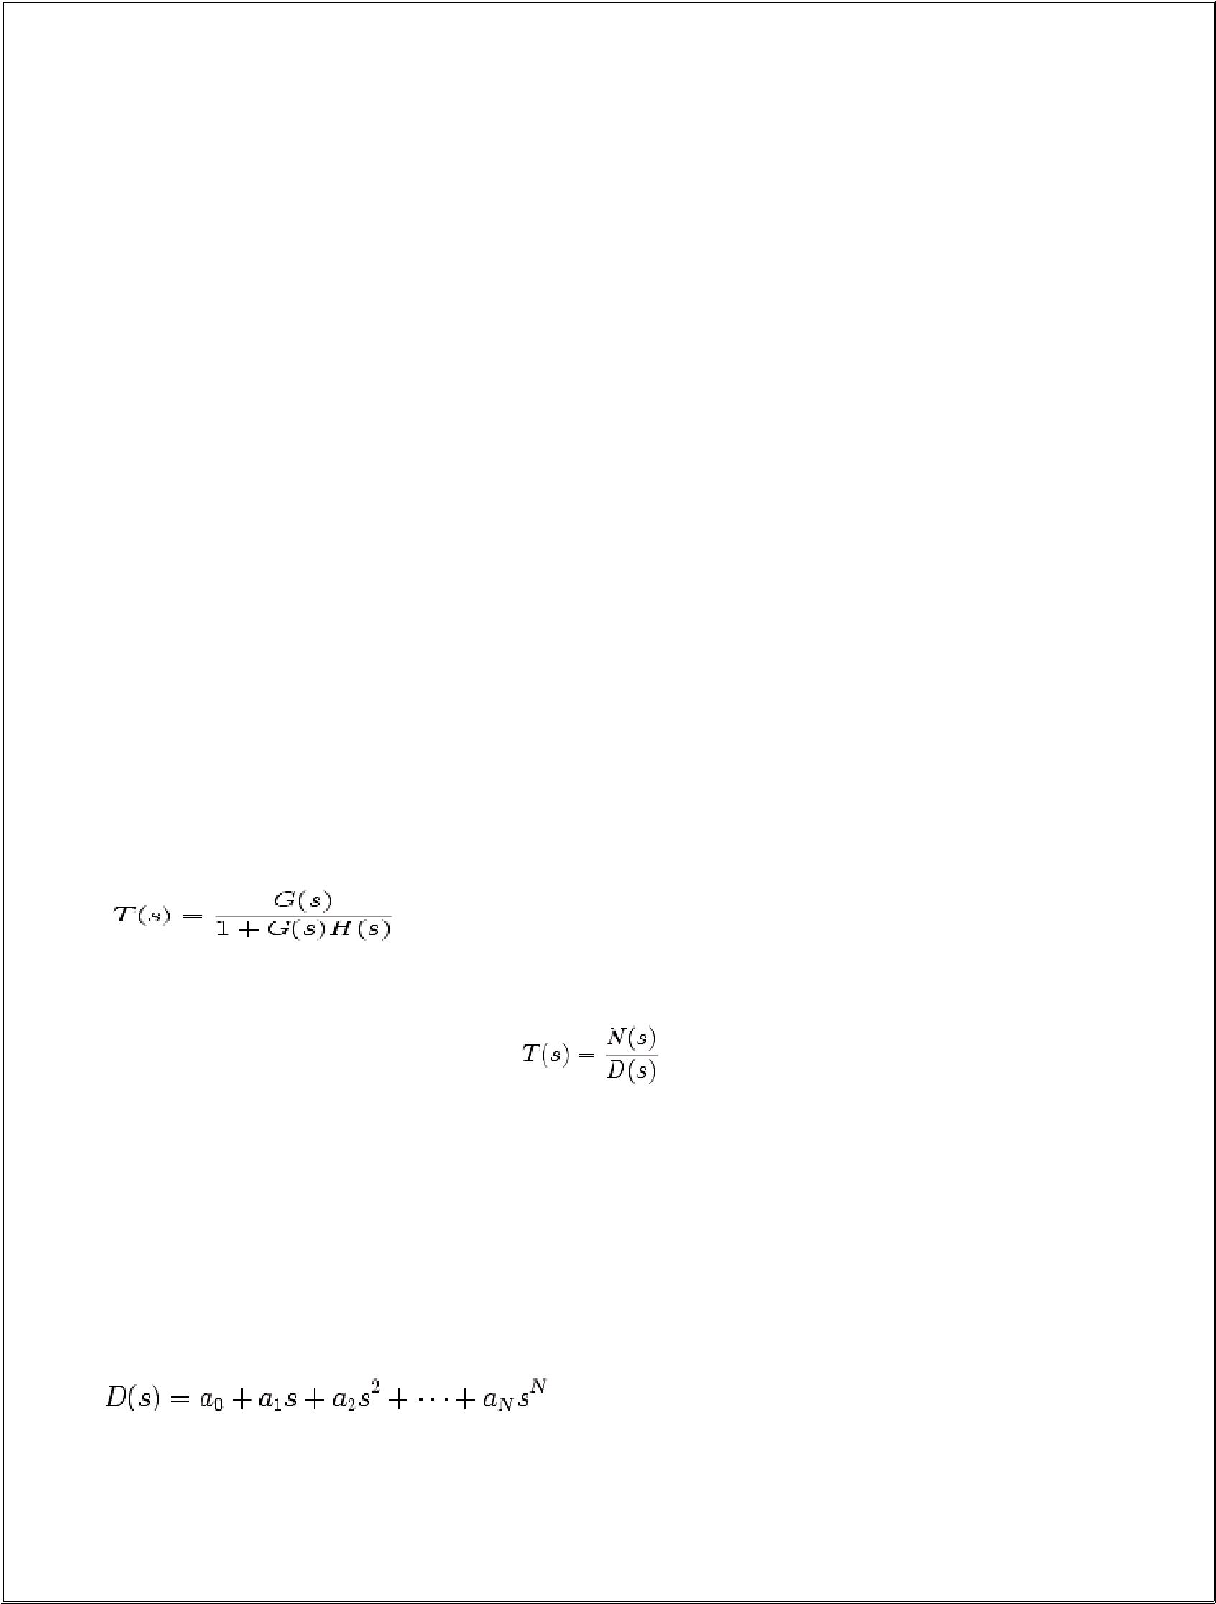
2

STSBILITY OF THE SYSTEM

4.1 Stability Criteria

The Routh-Hurwitz stability criterion is a necessary and sufficient criterion to prove the stability of an LTIsystem.Necessary Conditions that are necessary must be satisfied for a system to be stable, but conditions that satisfy these conditions might not all be stable. Necessary conditions may return "false positives", but will never return "false negatives". Sufficient Sufficient conditions are conditions that if met show the system to be definatively stable. Sufficient conditions may not be necessary, and they may return false negatives. The Routh-Hurtwitz criteria is both necessary and sufficient: A system must pass the RH test, and once it passes the test, it is definately stable.

4.2 Routh-Hurwitz Criteria

The Routh-Hurwitz criteria is comprised of three separate tests that must be satisfied. If any test fails, the system is not stable. Also, if any single test fails, any further tests need not be performed. For this reason, the tests are arranged in order from the easiest to determine to the hardest to determine. Routh Hurwitz test is performed on the denominator of the transfer function, the characteristic equation.

For instance, in a closed-loop transfer function with G(s) in the forward path, and H(s) in the feedback loop, we have:

If we simplify this equation, we will have an equation with a numerator N(s), and a denominator D(s):

4.3 Routh-Hurwitz Tests

Here are the three tests of the Routh-Hurwitz Criteria. For convenience, we will use N as the order of the

polynomial (the value of the highest exponent of s in D(s)). The equation D(s) can be represented generally as follows:

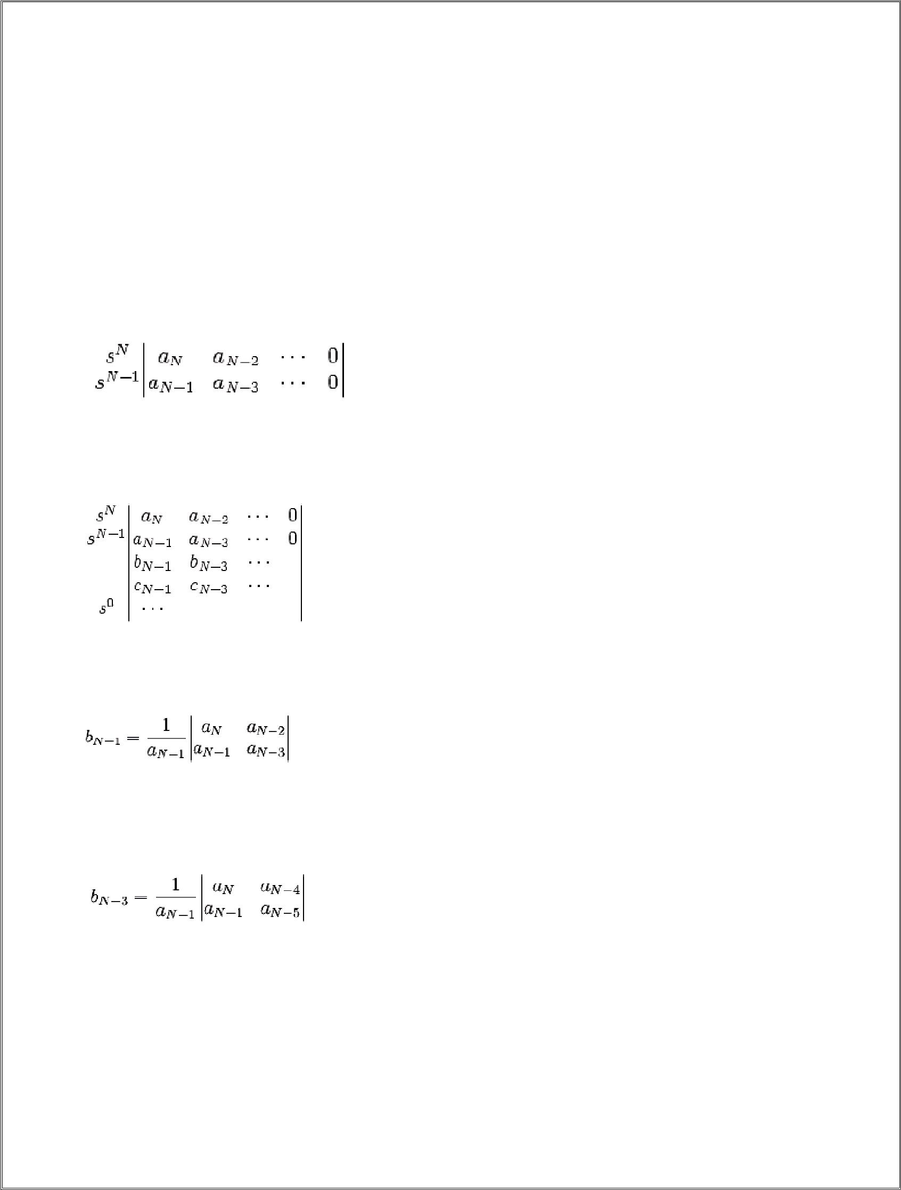
3

Rule 1:All the coefficients ai must be present (non-zero)

Rule 2:All the coefficients ai must be positive

Rule 3:If Rule 1 and Rule 2 are both satisfied, then form a Routh array from the coefficients ai. There is one pole in the right-hand s-plane for ever sign change of the members in the first column of the Routh array (any sign changes, therefore, mean the system is unstable).We will explain the Routh array below.

4.4 The Routh Array

The Routh array is formed by taking all the coefficients ai of D(s), and staggering them in array form. The final columns for each row should contain zeros:

Therefore, if N is odd, the top row will be all the odd coefficients. If N is even, the top row will be all the even

coefficients. We can fill in the remainder of the Routh Array as follows

Now, we can define all our b, c, and other coefficients, until we reach row s0. To fill them in, we use the following formulae:

And

For each row that we are computing, we call the left-most element in the row directly above it the pivot

element.For instance, in row b, the pivot element is and in row c, the pivot element is and so on and so forth until we reach the bottom of the array.

To obtain any element, we take the determinant of of the following matrix, and divide by the pivot element:

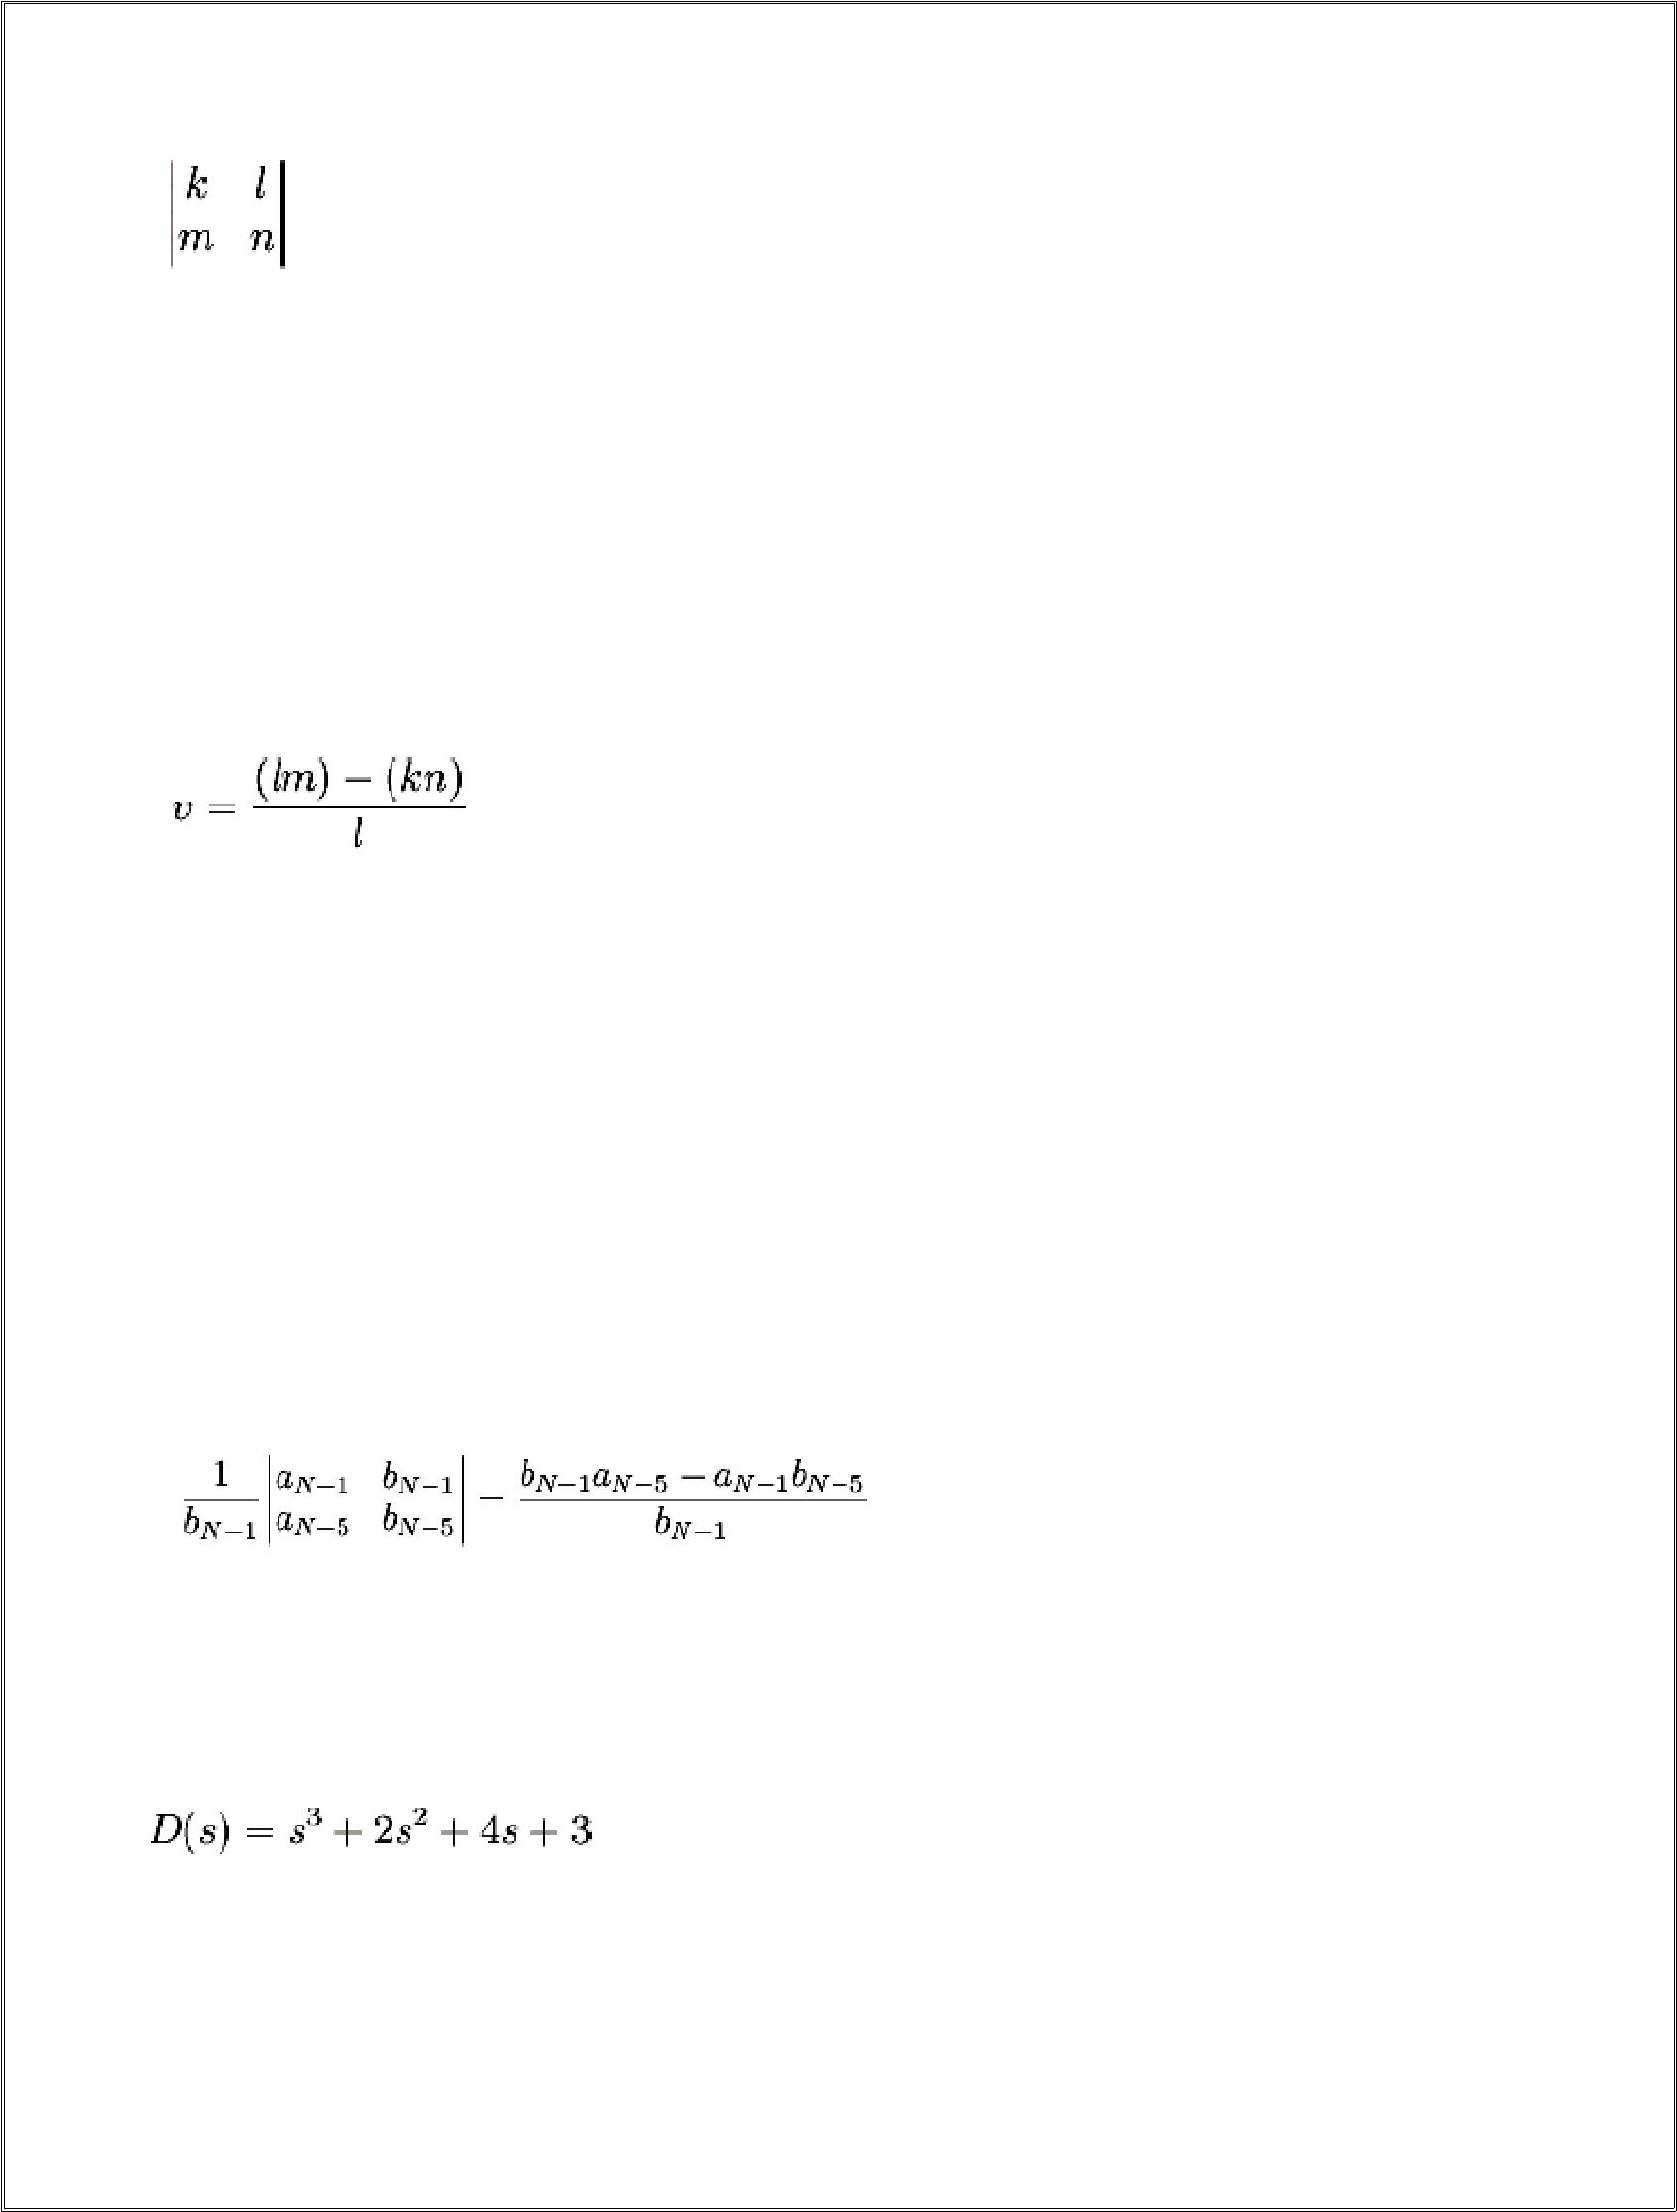
4

Where:

k is the left-most element two rows above the current row. l is the pivot element.

m is the element two rows up, and one column to the left of the current element. n is the element one row up, and one column to the left of the current element.

In terms of k l m n, our equation is:

Example: Calculating

To calculate the value CN-3, we must determine the values for k l m and n: k is the left-most element two rows up: aN-1

l the pivot element, is the left-most element one row up: bN-1

m is the element from one-column to the right, and up two rows: aN-5 n is the element one column right, and one row up: bN-5

Plugging this into our equation gives us the formula for CN-3:

Example: Stable Third Order System

We are given a system with the following characteristic equation:

Using the first two requirements, we see that all the coefficients are non-zero, and all of the coefficientsare positive. We will proceed then to construct the Routh-Array:

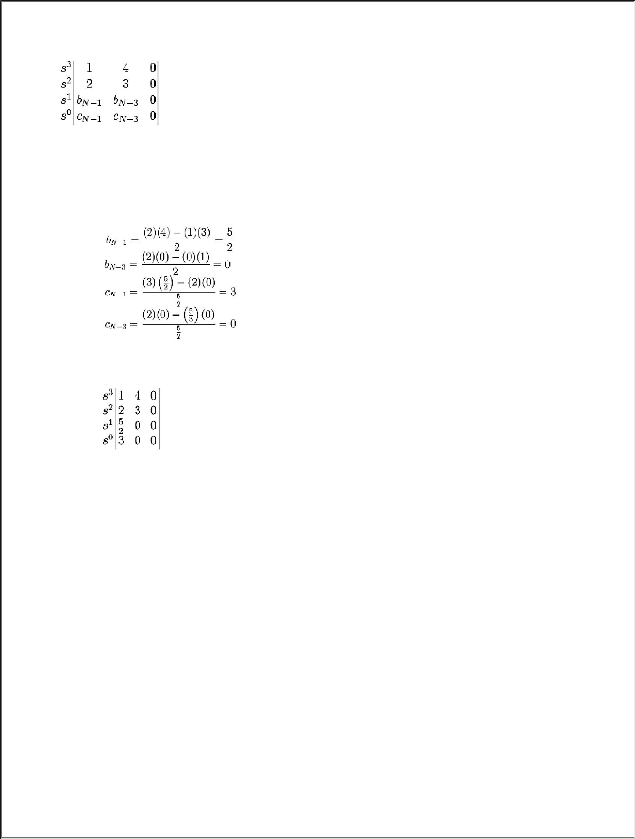
5

And we can calculate out all the coefficients:

And filling these values into our Routh Array, we can determine whether the system is stable:

From this array, we can clearly see that all of the signs of the first column are positive, there are no sign changes, and therefore there are no poles of the characteristic equation in the RHP.

4.5 Special cases:

- The properties of the table do not change when all the coefficients of a row are multiplied by the same positive number.

- If the first-column term becomes zero, replace 0 by ξ and continue.

- If the signs above and below a ξ re the same, then there is a pair of (complex) imaginary roots.

- If there is a sign change, then there are roots with positive real parts.

Examples:

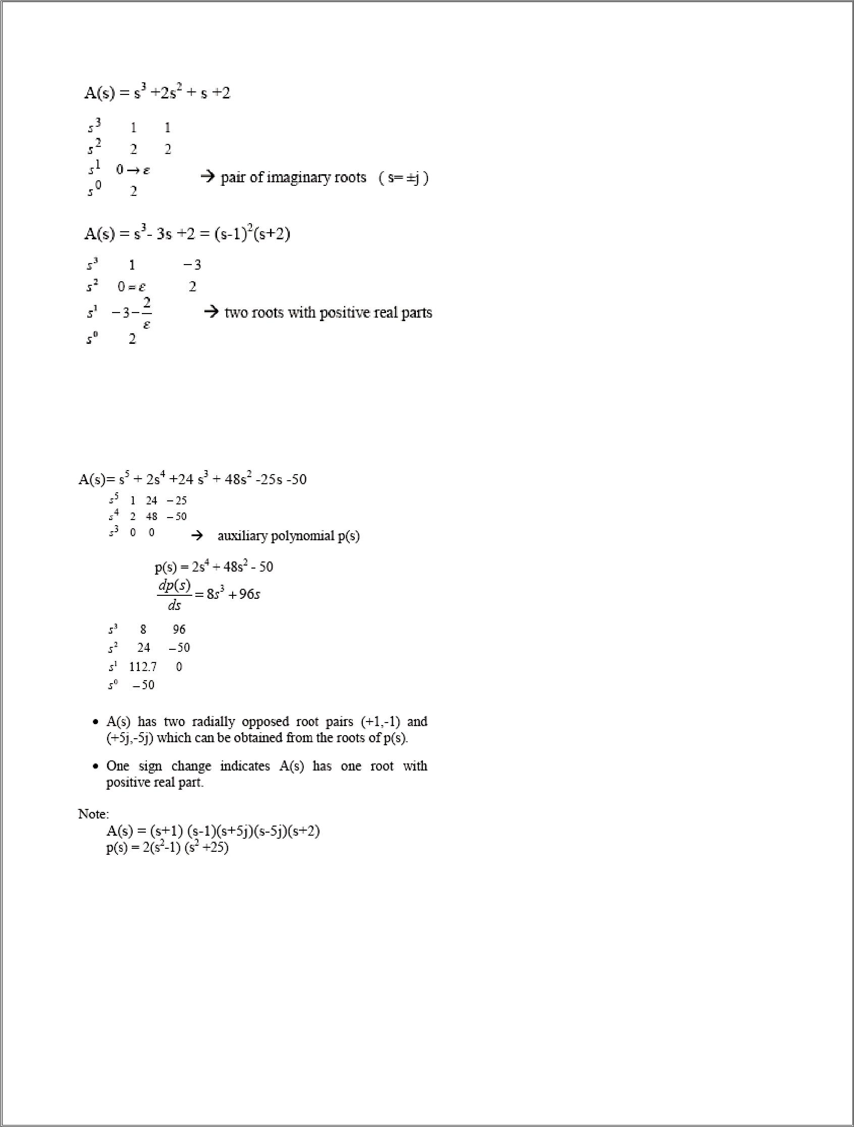
6

3. If all coefficients in a line become 0, then A(s) has roots of equal magnitude radially opposed on the real or imaginary axis. Such roots can be obtained from the roots of the auxiliary polynomial.

Example:

7

Fourier series

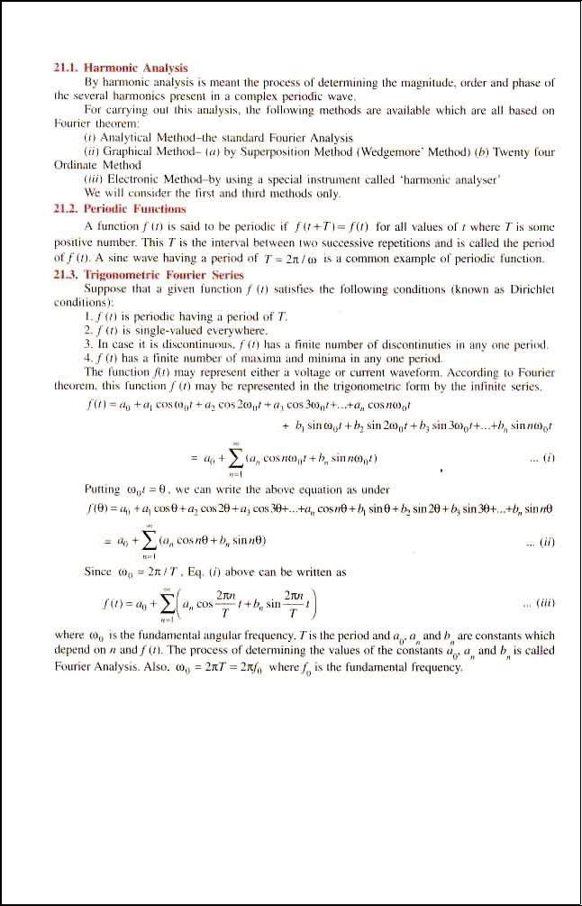
8
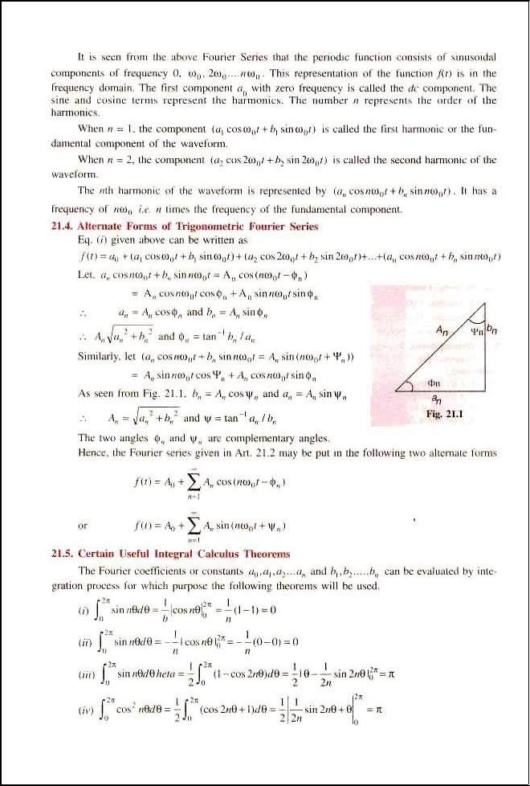
9

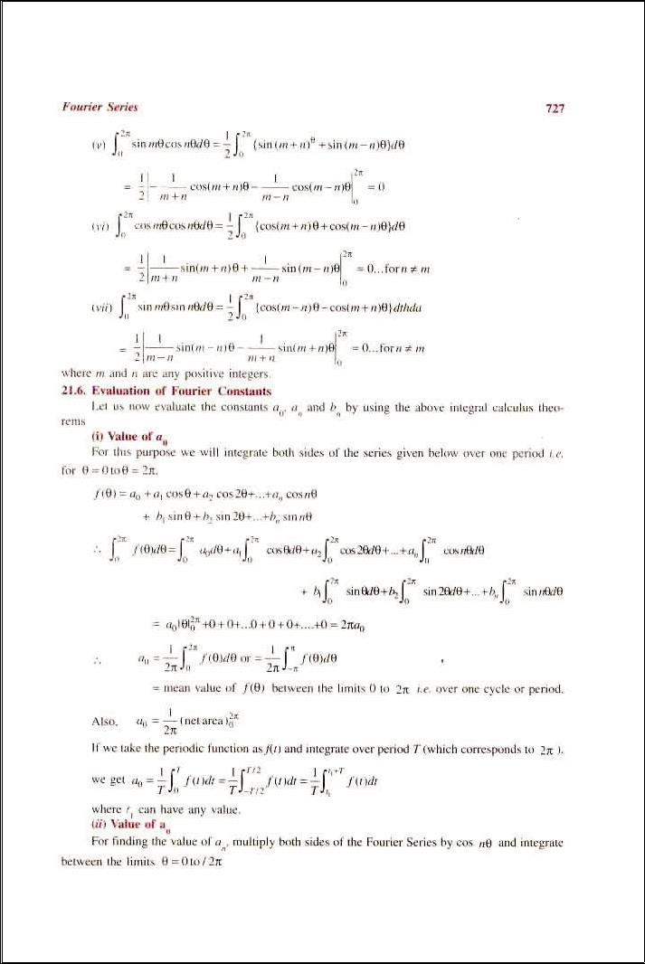
10

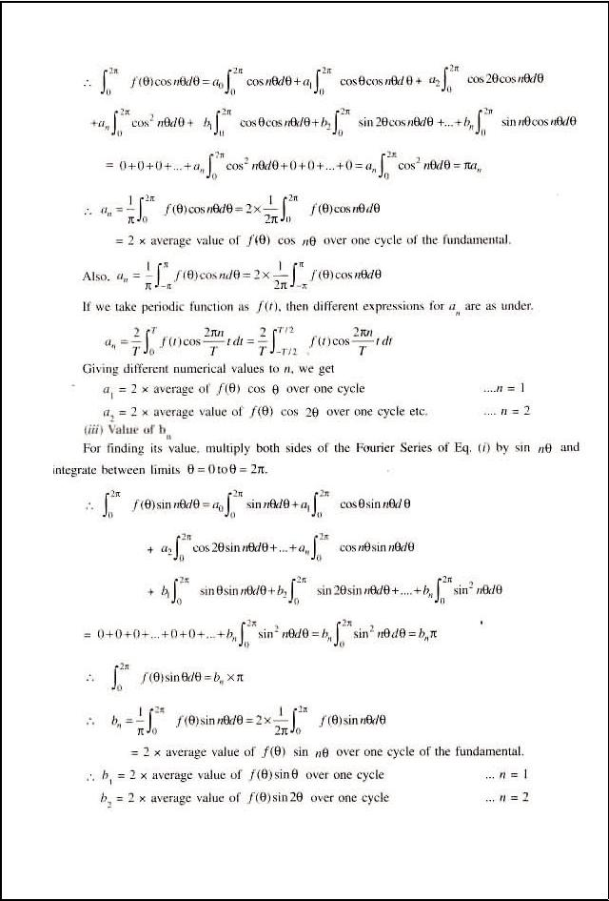
11

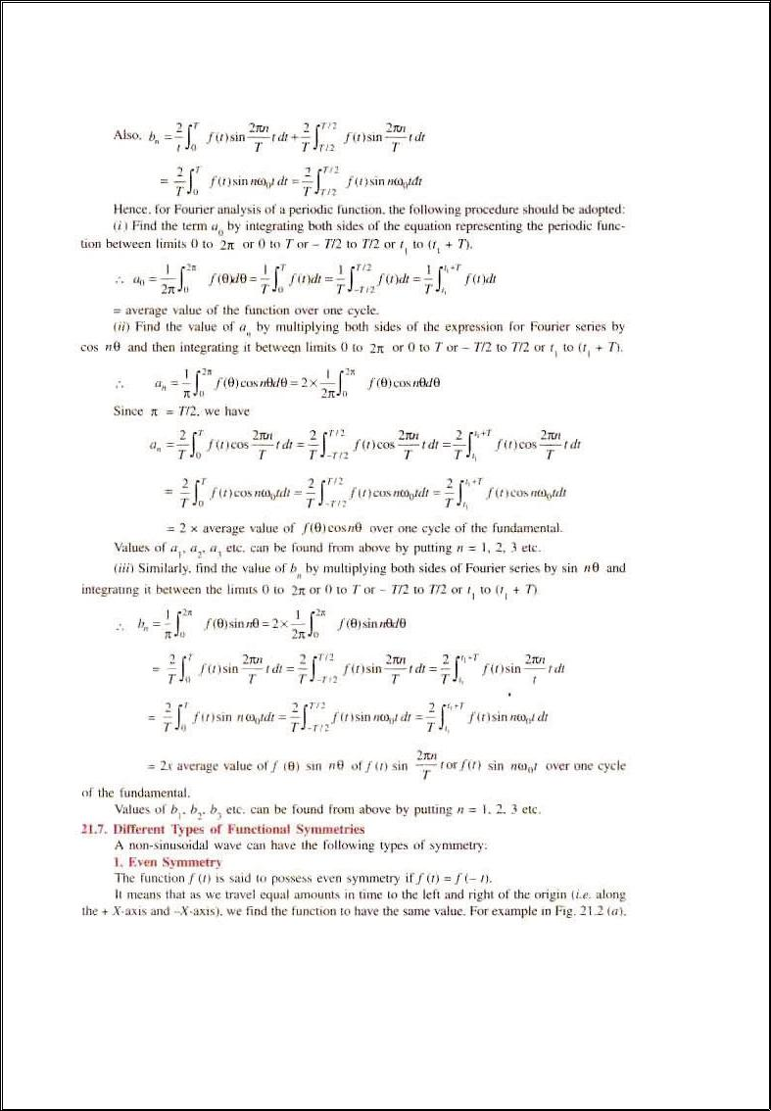
12

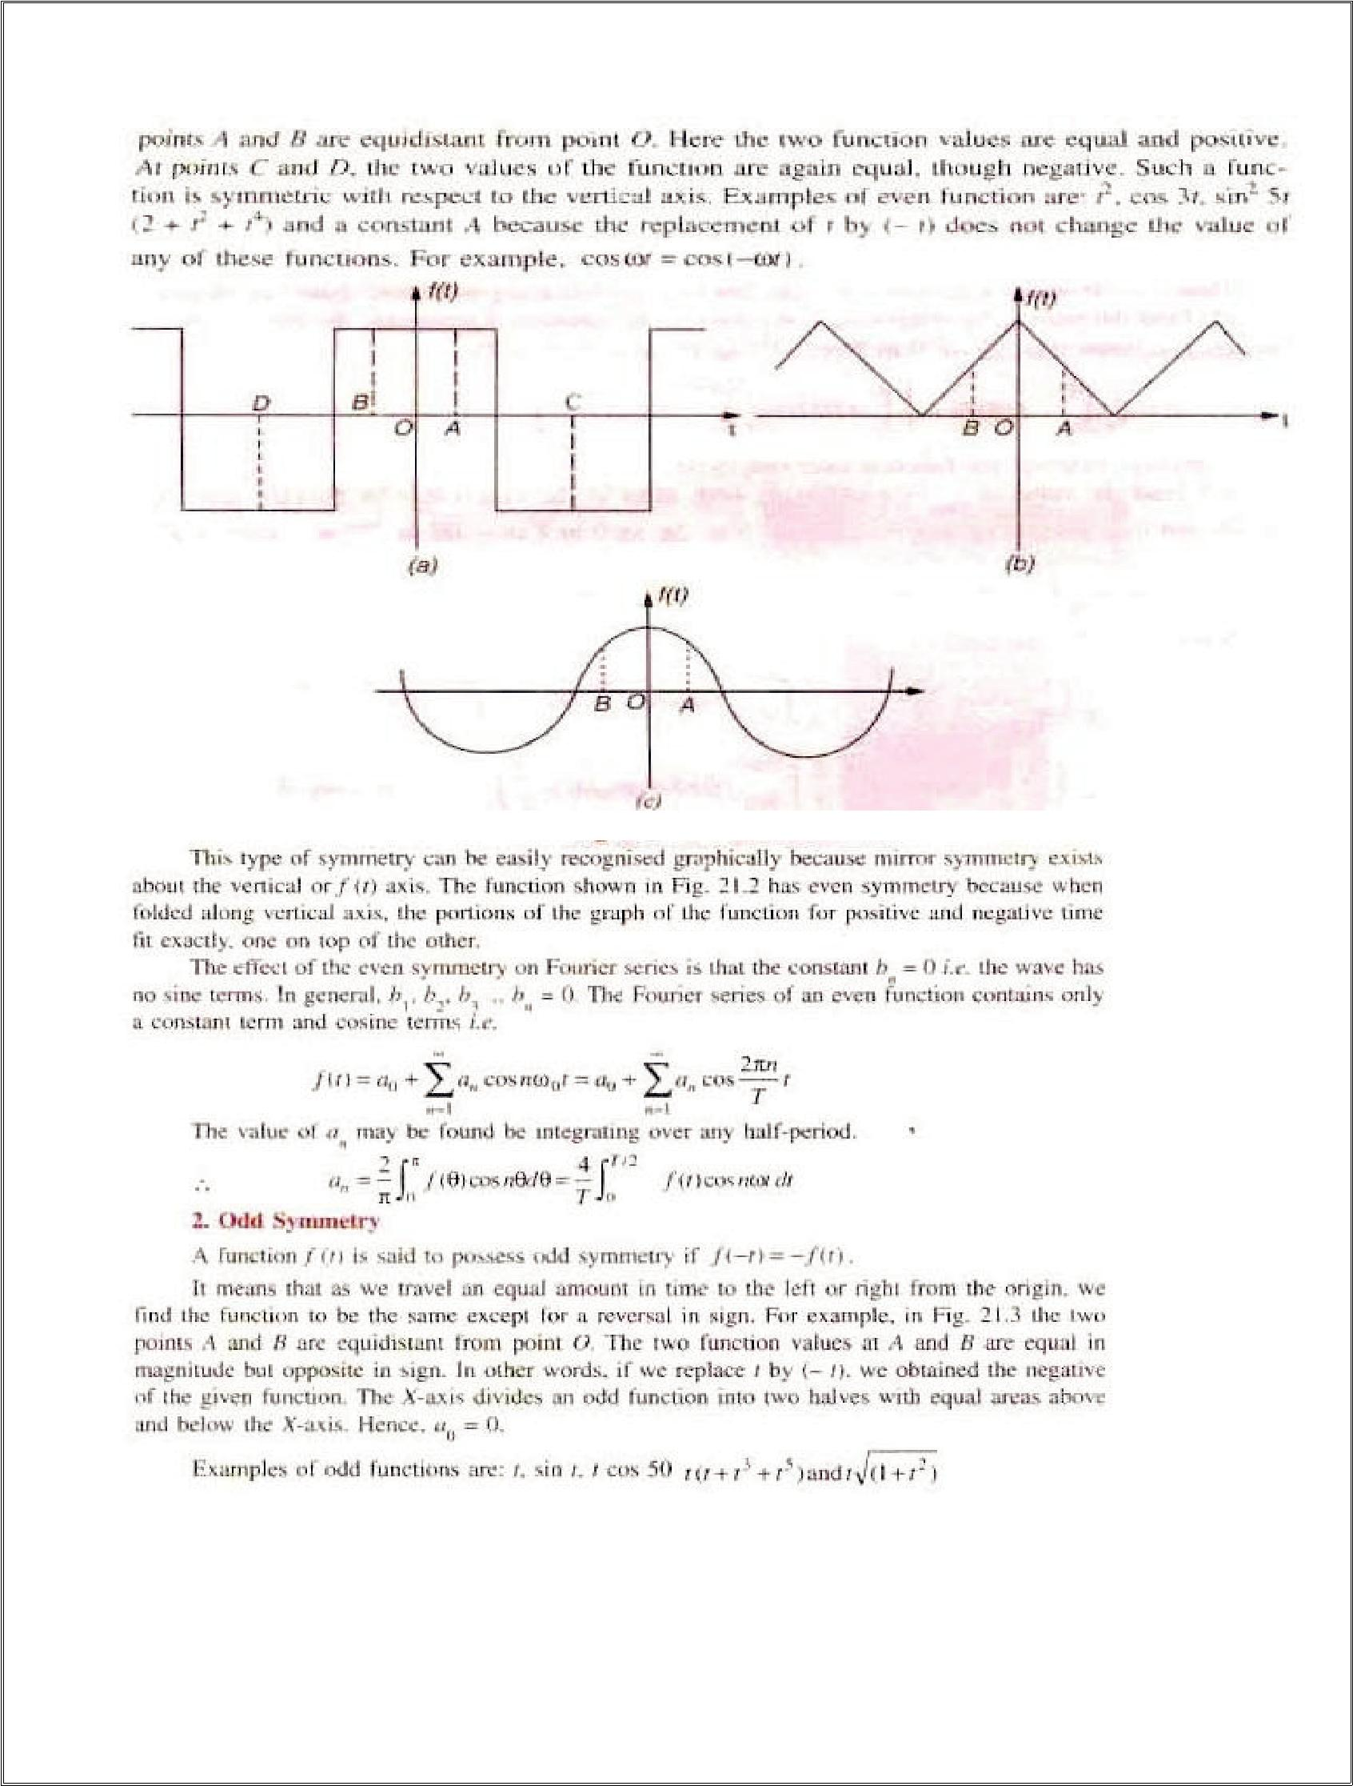
13

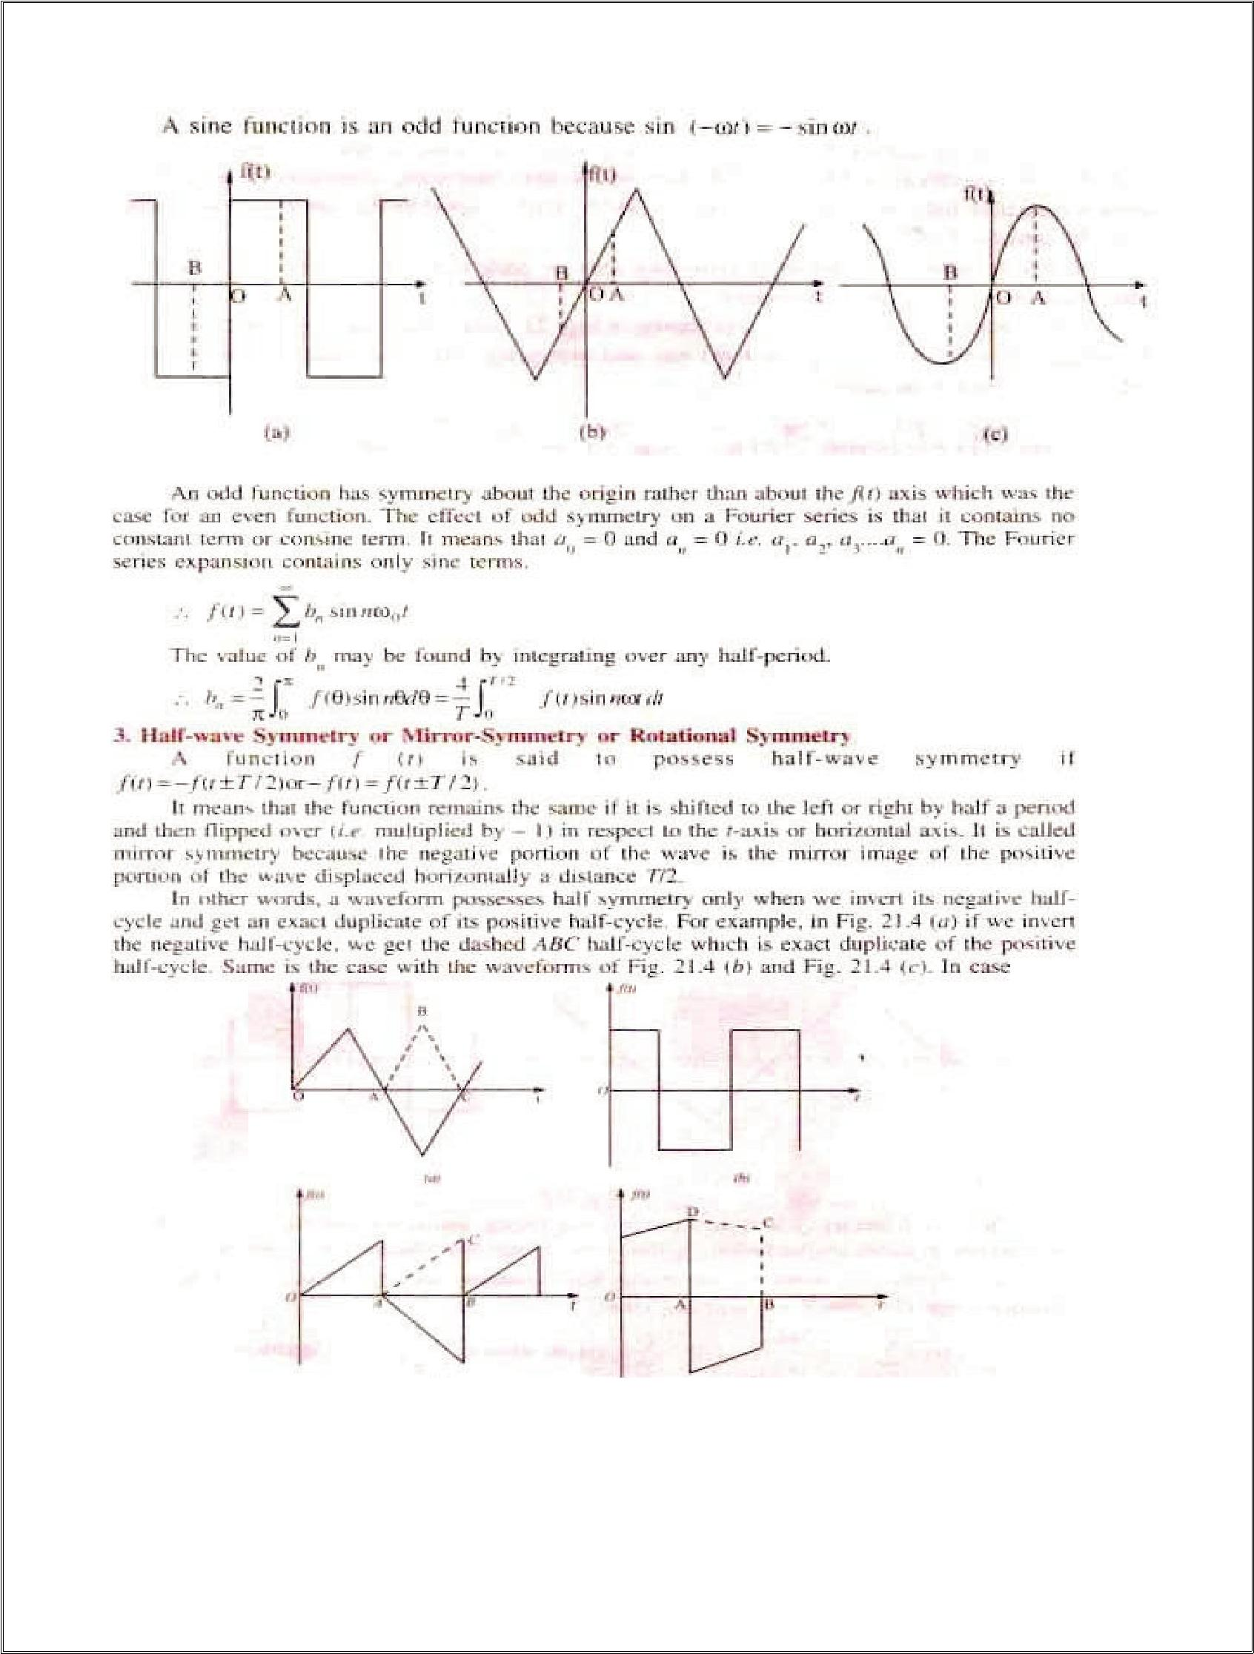
14

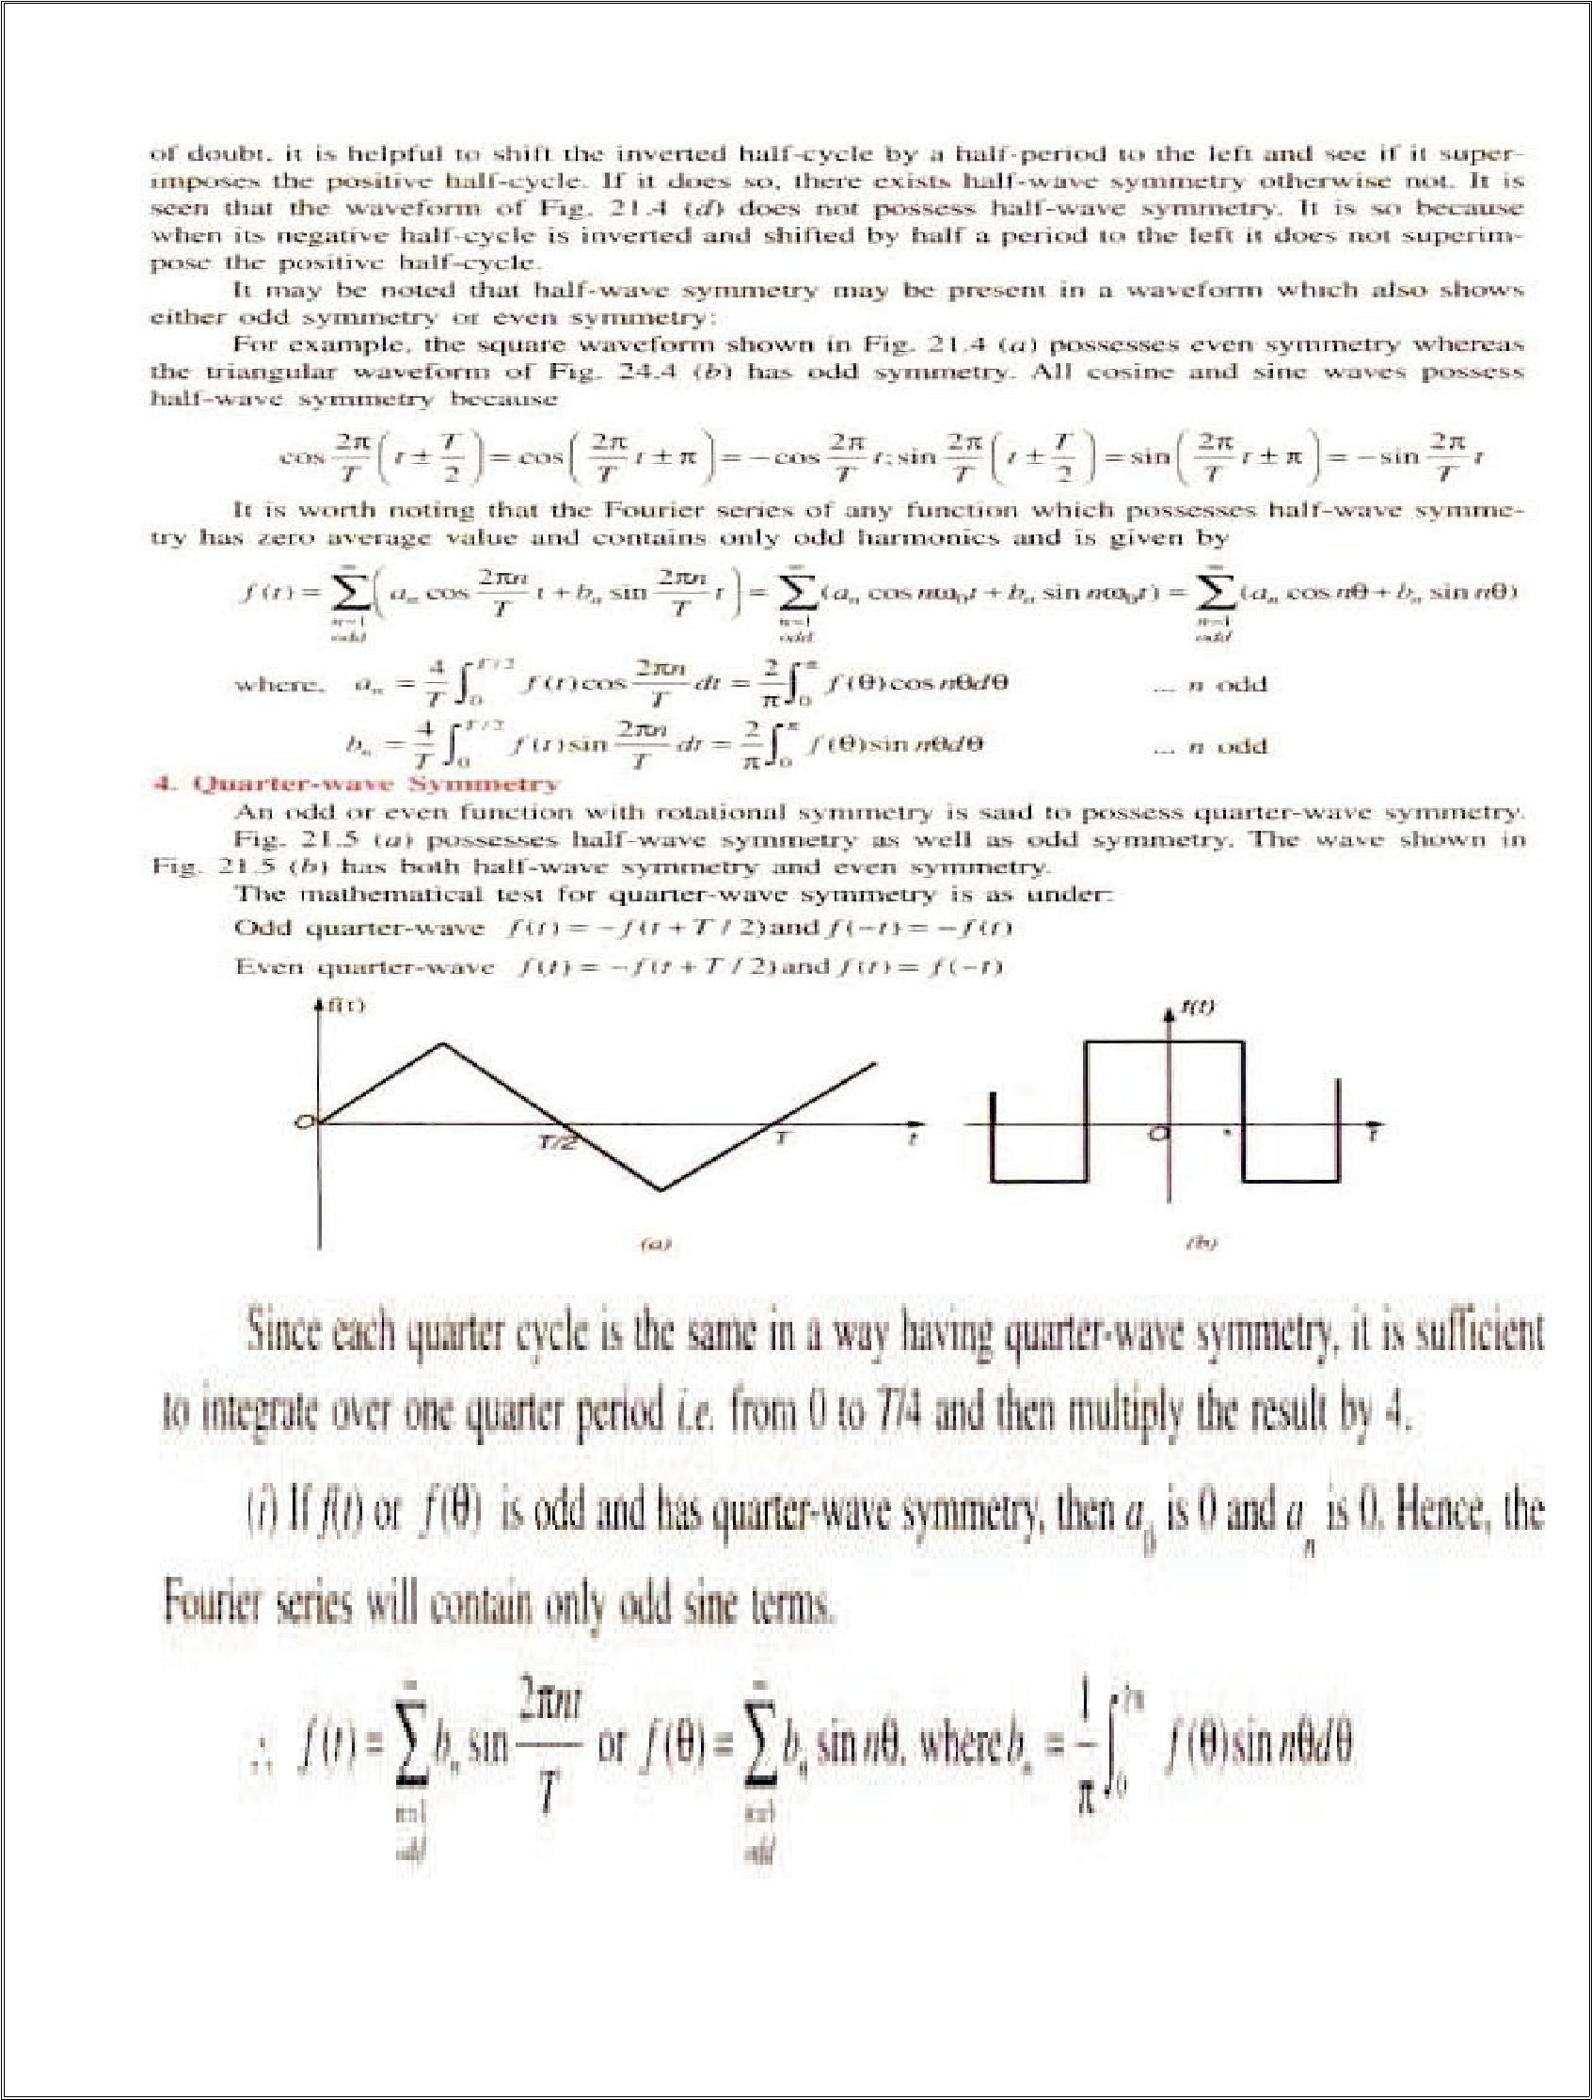
15

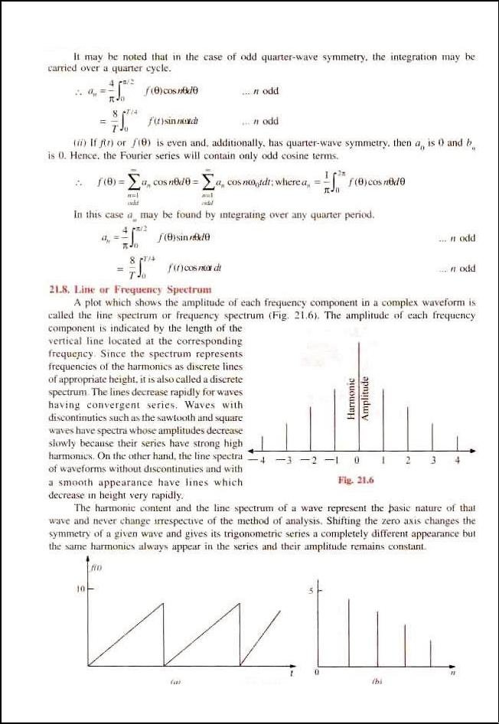
16

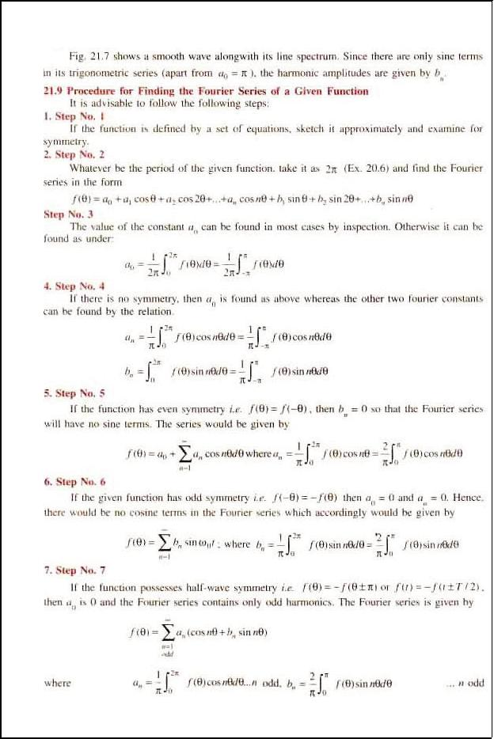
17

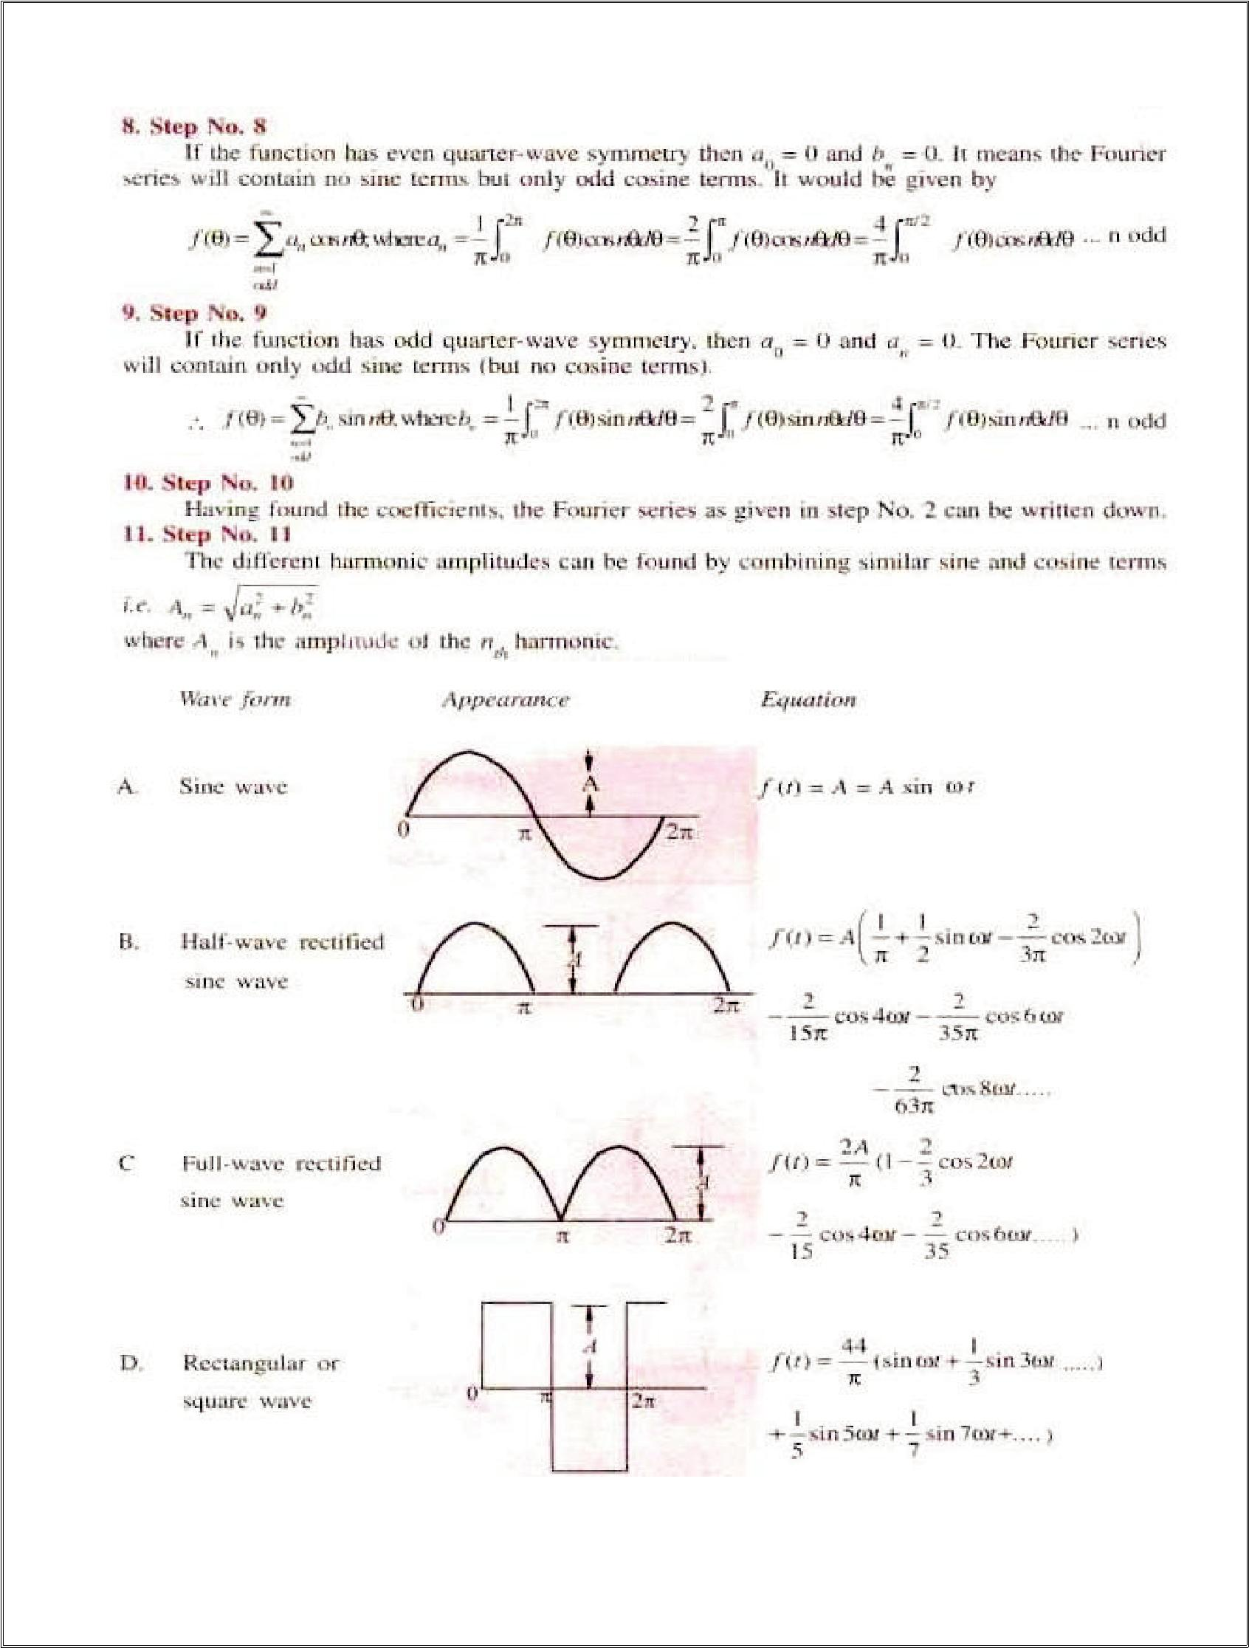
18

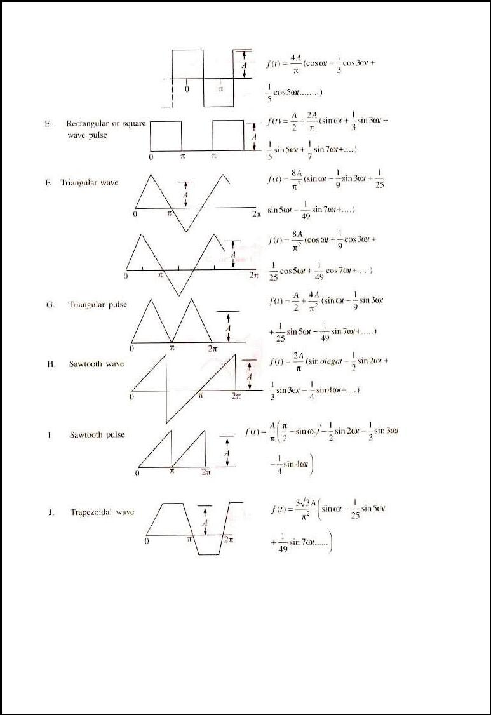
19

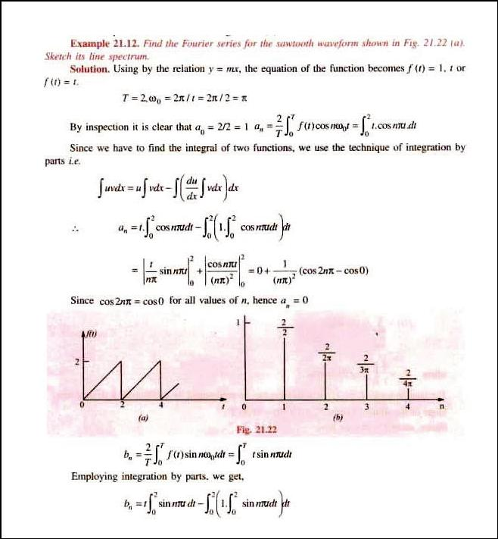
20

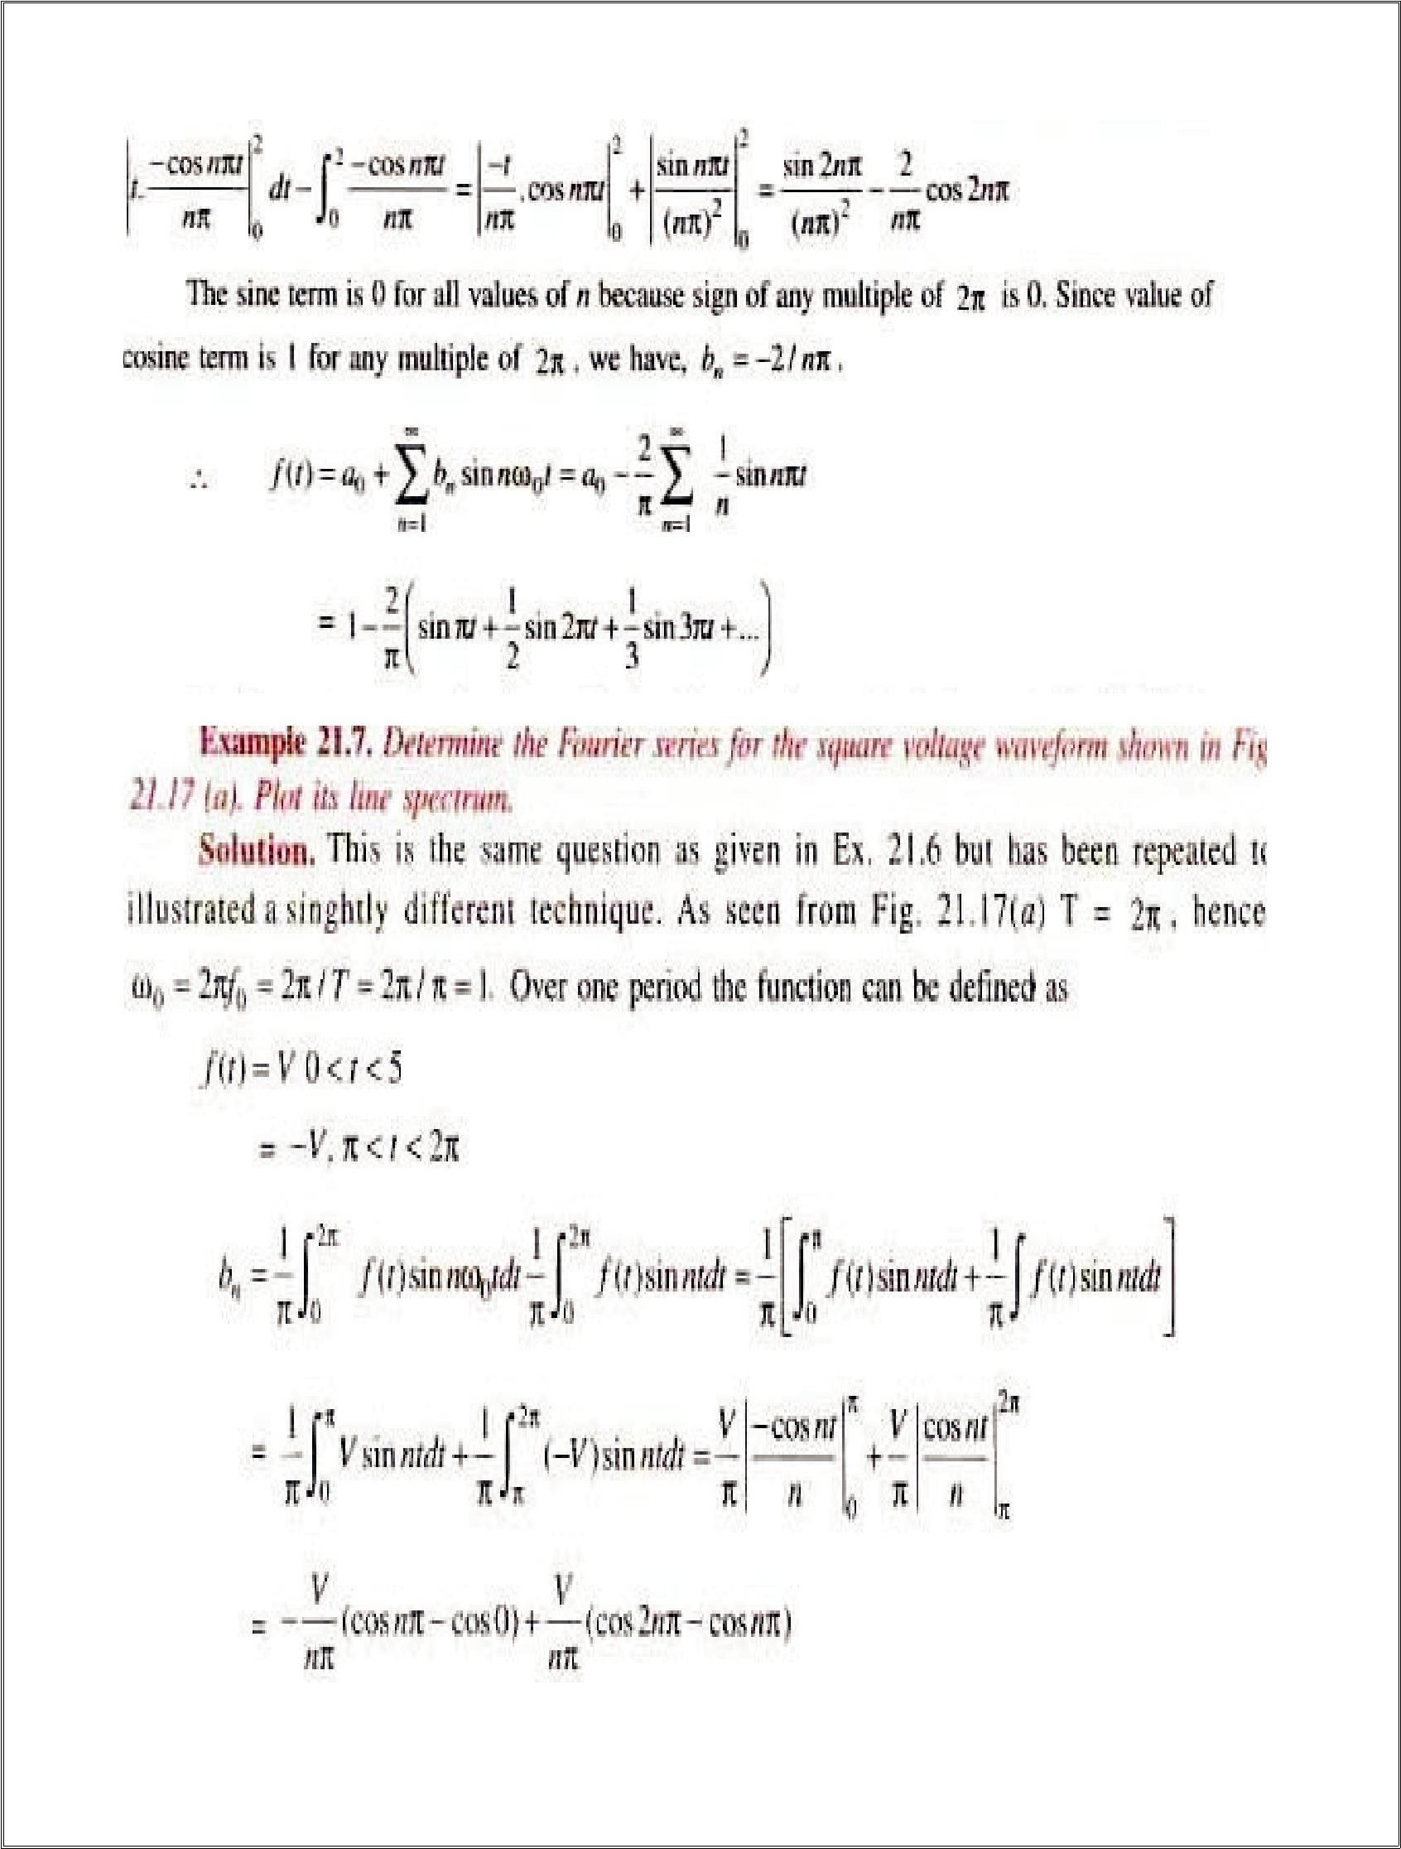
21

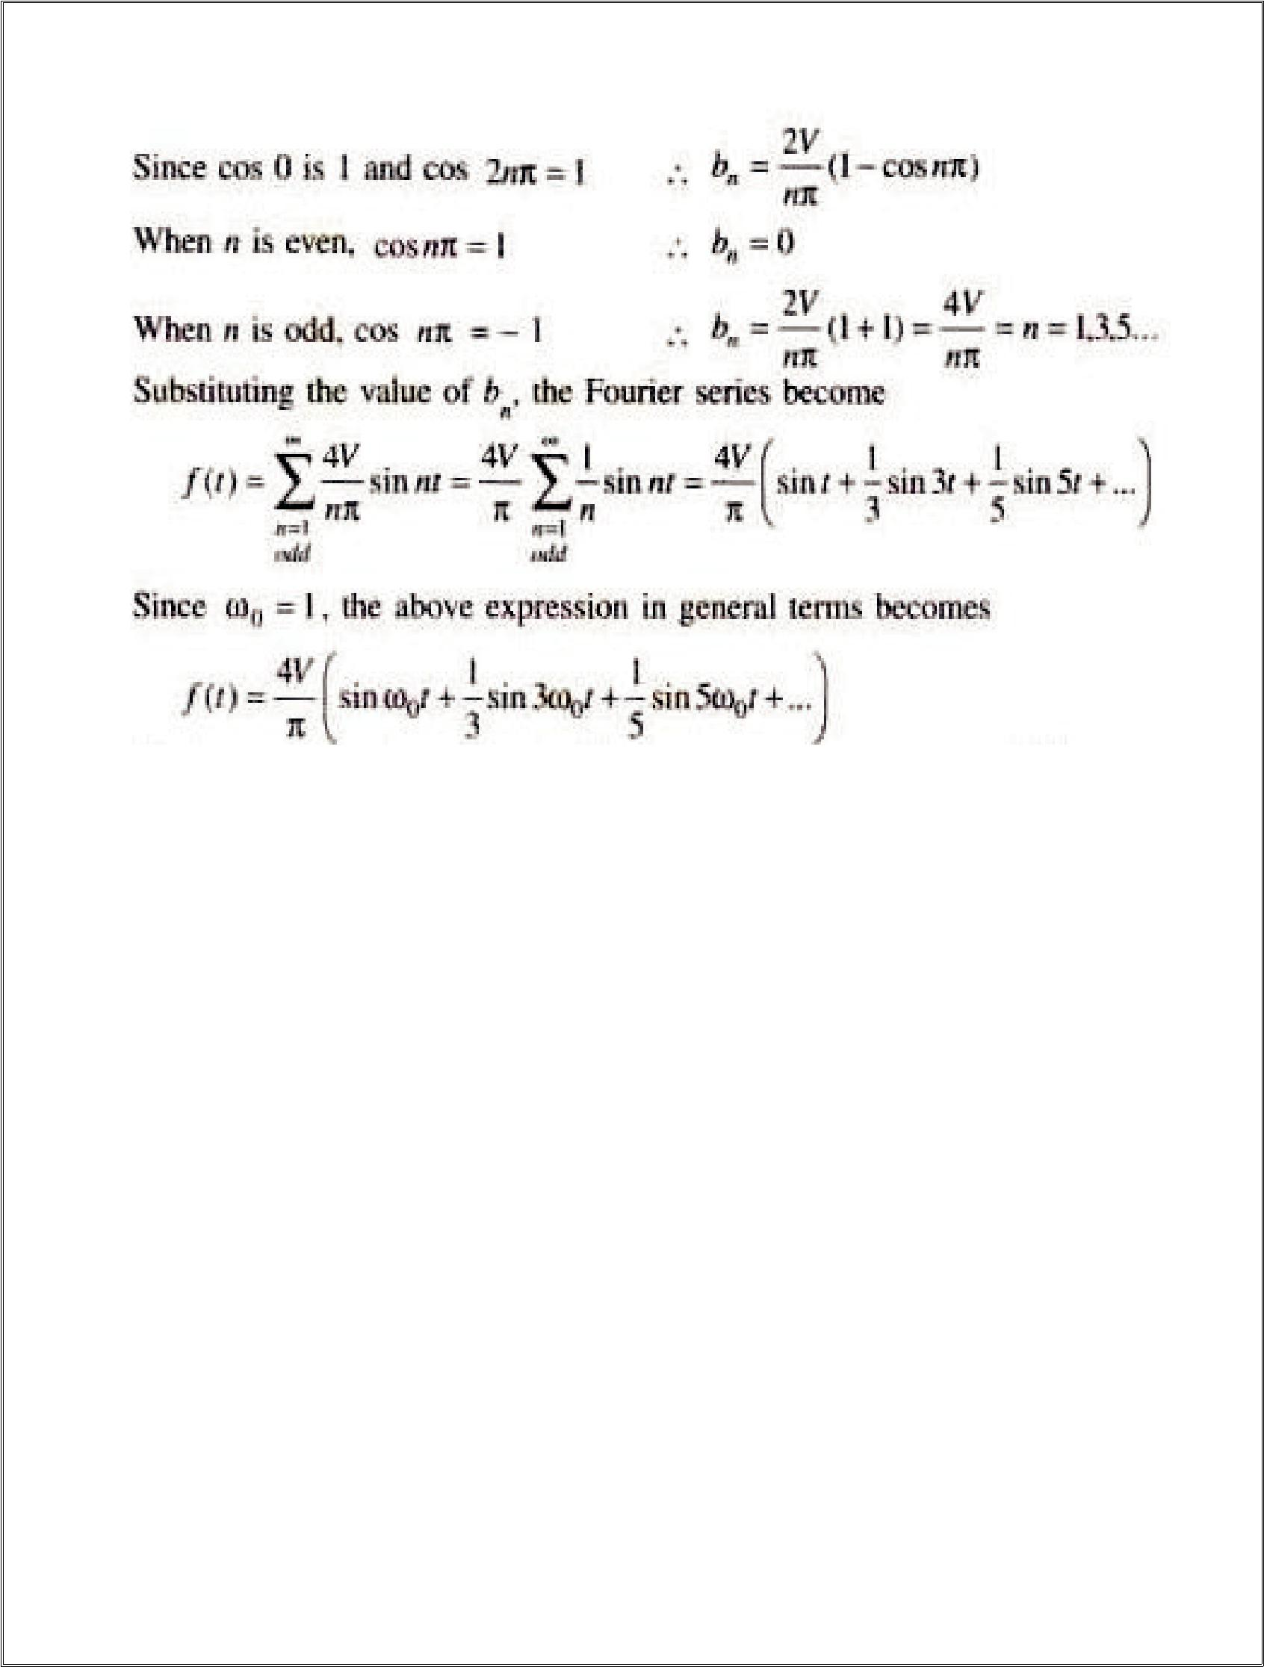
22

Beyond syllabus
A time domain signal, x(t), is assessed by the behaviour of its magnitude over an infinite time interval. As time tends to infinity, the absolute value of the signal magnitude can either: (a) continuously decrease and/or increase (or stay constant) but remain within a bounded range (b) continuously increase to very large values without any bound Figures 10.21 and 10.22 show examples of bounded exponential signals and bounded sinusoidal signals. We can see that the magnitude of an exponential function, eat, with a < 0, will decrease to zero as time tends to infinity. The magnitude of a unit step function is finite since its value is 1, even when time tends to infinity. We call these types of signals bounded.

